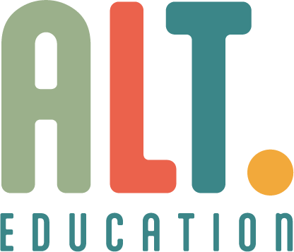

Pupil Premium Policy

Approved by:  Holly Delahunty |  | Date:  06/08/2025
Last reviewed on:
06/08/2025
Next review due by:
06/08/2026

Alt Nottingham Ltd is committed to ensuring that all pupils, regardless of background or financial circumstance, have equal access to high-quality education and support. We use Pupil Premium funding strategically to close attainment gaps and promote positive outcomes for disadvantaged learners.
1. Legal Framework and Guidance
This policy is informed by the following statutory and non-statutory guidance:
- Pupil Premium Overview – GOV.UK
- Using Pupil Premium: Guidance for School Leaders – GOV.UK
- EEF Guide to the Pupil Premium – Education Endowment Foundation
2. Eligibility
Pupil Premium funding is allocated for:
- Pupils eligible for Free School Meals (FSM)
- Pupils who have been eligible for FSM at any point in the last 6 years (Ever 6)
- Looked-after children (LAC)
- Previously looked-after children (PLAC)
- Children of armed forces personnel (Service Pupil Premium)
3. Principles
Alt Nottingham Ltd will:
- Use evidence-based approaches to support disadvantaged pupils
- Ensure funding is targeted and transparent
- Monitor impact rigorously and adapt strategies as needed
4. Strategic Use of Funding
Funding is used to:
- Provide targeted academic support (e.g. tutoring, literacy interventions)
- Enhance emotional wellbeing and mental health provision
- Support attendance and engagement
- Offer enrichment opportunities and cultural capital experiences
- Deliver mentoring and personalised learning pathways
5. Monitoring and Evaluation
- Pupil progress is tracked termly using academic and wellbeing indicators
- Strategy effectiveness is reviewed annually
- Feedback from pupils, staff, and families informs future planning
- Outcomes are reported to governors and commissioning schools

6. Accountability
- The Head of Provision and SEND Lead oversee the implementation and review of Pupil Premium strategies.

