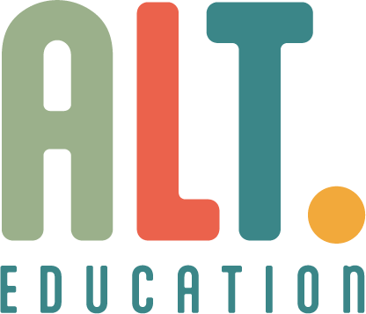

Modern Slavery Policy

Approved by:  Holly Delahunty |  | Date:  03/08/2025
Last reviewed on:
03/08/2025
Next review due by:
03/08/2027
Alt Nottingham Alternative Provision is committed to upholding the highest standards of ethical conduct and integrity in all areas of our work. We recognise our duty under the Modern Slavery Act 2015 to prevent modern slavery and human trafficking in our operations and supply chains. We do not tolerate any form of forced labour, servitude, or exploitation.
Our Structure and Operations
Alt Nottingham provides tailored educational support for young people through alternative provision pathways. While we do not have complex supply chains, we remain vigilant in our procurement processes and work only with trusted suppliers who demonstrate compliance with ethical standards.
Policies and Practices
We promote transparency, dignity, and fair treatment through policies that reflect our safeguarding responsibilities and commitment to human rights. This includes:
- Rigorous safeguarding procedures embedded across our setting
- Vetting of all contractors and service providers
- Clear whistleblowing procedures enabling staff and stakeholders to raise concerns confidentially
Risk Assessment and Mitigation
While our risk of modern slavery is low, we routinely assess activities and relationships that could present vulnerability. This includes:
- Ensuring any outsourced services (e.g. catering, cleaning, student transport) meet compliance checks
- Monitoring for signs of exploitation or coercion among students and families as part of pastoral support and safeguarding protocols
Training and Awareness
Staff are supported to identify, and report concerns through regular safeguarding training, which includes guidance on recognising signs of modern slavery. DSLs are trained to respond appropriately and escalate concerns to external authorities.
Monitoring and Review
This statement is reviewed annually or following significant changes in operations or legislation. We continue to refine our safeguarding culture and maintain open channels to support reporting, transparency, and accountability.
Approval
This statement has been approved by the Senior leadership of Alt Nottingham Alternative Provision. It reflects our unwavering commitment to protecting vulnerable individuals and promoting safe and ethical practice.

